The University Of Azad Jammu & Kashmir

Student Name: Qurat Ul Ain Fatima
Roll No: 2024-SE-05
Course Title: Software construction & Development
Course Code: SE-3101
Course Instructor: Engr. Dr. Asma Javaid
DEPARTMENT OF SOFTWARE ENGINEERING

LAB # 02
According to Lab 2 , there are three tasks: a Foodpanda activity diagram using swimlanes, a toaster state machine diagram, and an elevator/lift state machine diagram.

Foodpanda Online Food Ordering — Activity Diagram with Swimlanes

Objective
The objective of this task is to draw an activity diagram that represents the complete process of ordering food through the Foodpanda application. The diagram uses swimlanes to divide the activities among four participants: Customer, Foodpanda App, Restaurant, and Delivery Rider.

Explanation of the Diagram
The diagram illustrates the steps involved in placing a food order, processing payment, preparing the food, and delivering it to the customer.
1. Customer Swimlane
The process begins when the customer opens the Foodpanda application. The customer browses the available restaurants, selects food items, and adds them to the shopping cart. After selecting the desired food, the customer proceeds to checkout and enters the delivery address.
The customer then selects a payment method to pay for the order. After the order has been processed, the customer can view the order status and estimated delivery time. Finally, the customer receives the food delivered by the rider.
2. Foodpanda App Swimlane
The Foodpanda application manages the ordering process and communicates with the restaurant.
After the customer proceeds to checkout, the application displays the available payment options. The customer completes the payment process, and the application checks whether the payment is successful.
There are two possible outcomes:
- If payment is successful: The application sends the order to the restaurant so that food preparation can begin.
- If payment fails: The application displays a payment error and allows the customer to try again by selecting a payment option.
The application also tracks the order and notifies the customer about its progress. When the order is ready for delivery, the application updates the order status to indicate that it is out for delivery.
3. Restaurant Swimlane
The restaurant receives the order sent by the Foodpanda application and accepts it.
After accepting the order, the restaurant checks whether the required food items are available.
There are two possible outcomes:
- If the items are available: The restaurant prepares the food and assigns a delivery rider to collect it.
- If the items are unavailable: The restaurant notifies the customer, and the order is cancelled or refunded as appropriate.
Once the food is prepared, the restaurant hands it over to the assigned delivery rider.
4. Delivery Rider Swimlane
The delivery rider collects the prepared order from the restaurant and delivers it to the customer's address.
After delivery, the customer receives the order. The application updates the delivery status so the customer can follow the progress of the order.

Conclusion
This activity diagram explains the complete online food ordering process in the Foodpanda application. It shows how the customer, application, restaurant, and delivery rider work together to complete an order. It also represents decision-making situations, such as payment failure and food unavailability, demonstrating how the system handles different outcomes.
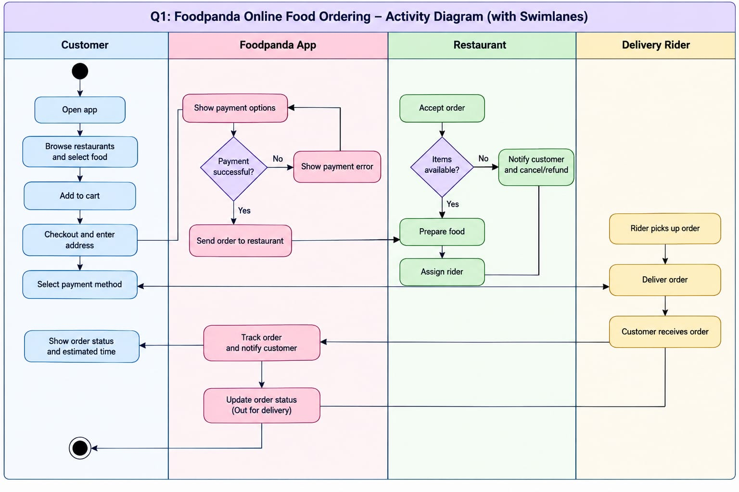

Toaster — UML State Machine Diagram

Objective
The objective of this task is to draw a UML state machine diagram for a toaster. The diagram represents the different states of the toaster, the activities performed in each state, and the events that cause the toaster to change from one state to another.

Explanation of the Diagram
The toaster moves through different states depending on user actions, elapsed time, temperature conditions, and faults. The diagram contains six main states: Off, Heating, Toasting, Ejecting, Finished, and Fault.
1. Initial State
The black circle represents the initial state of the toaster. When the toaster is plugged in and powered on, the process begins and the toaster enters the Off state.
2. Off State
In this state, the toaster is waiting for the user to start the toasting process.
The activity performed in this state is:
- Wait for the start command.
When the user presses the Start button, the toaster starts its timer and moves from the Off state to the Heating state.
3. Heating State
In the Heating state, the toaster powers its heating elements and begins heating the bread.
The activities performed in this state are:
- Power on the heating elements.
- Heat the bread.
When the bread reaches the required temperature, the temperatureReady event occurs, and the toaster transitions to the Toasting state.
If a fault occurs during heating, the toaster moves to the Fault state.
4. Toasting State
In this state, the toaster continues heating the bread to achieve the desired level of toasting.
The activities performed in this state are:
- Continue heating.
- Toast the bread.
When the preset timer expires, the timerExpired event occurs, and the toaster moves to the Ejecting state.
If the bread becomes jammed or stuck, the jamDetected event occurs, and the toaster moves to the Fault state.
5. Ejecting State
In this state, the toaster raises its lever to eject the toasted bread.
The activities performed in this state are:
- Raise the lever.
- Eject the bread.
When the lever is released, the leverReleased event occurs, and the toaster transitions to the Finished state.
The diagram also shows a fault-related transition from Ejecting to the Fault state.
6. Finished State
In this state, the toasting process has finished, and the toaster waits for the next reset or operation.
The activity performed in this state is:
- Wait for reset.
The diagram shows a pressStart / reset transition that returns the toaster to the Heating state to begin another toasting cycle.
7. Fault State
The Fault state represents an abnormal situation in which the toaster cannot continue its normal operation.
The activity performed in this state is:
- Cut power to the toaster.
The diagram shows that a cancellation or reset operation can return the toaster to the Off state, allowing it to return to normal operation when appropriate.

Events and Triggers in the Diagram
The diagram identifies the following events:
Event | Meaning
pressStart | The user presses the Start button.
temperatureReady | The bread reaches the required temperature.
timerExpired | The preset toasting time has elapsed.
leverReleased | The lever is pushed back or released.
jamDetected | The bread becomes jammed or stuck.
cancel | The current operation is cancelled.
reset | The toaster is reset after a fault.
The notation pressStart / start timer means that pressing the Start button triggers the action of starting the timer.
Similarly, plug in / power on indicates that plugging in the toaster causes the power-on action.

Conclusion
This state machine diagram represents the behaviour of a toaster from startup to heating, toasting, bread ejection, and completion. It also includes fault handling for abnormal conditions, such as jammed bread. The diagram demonstrates how events and actions control transitions between the toaster's states.
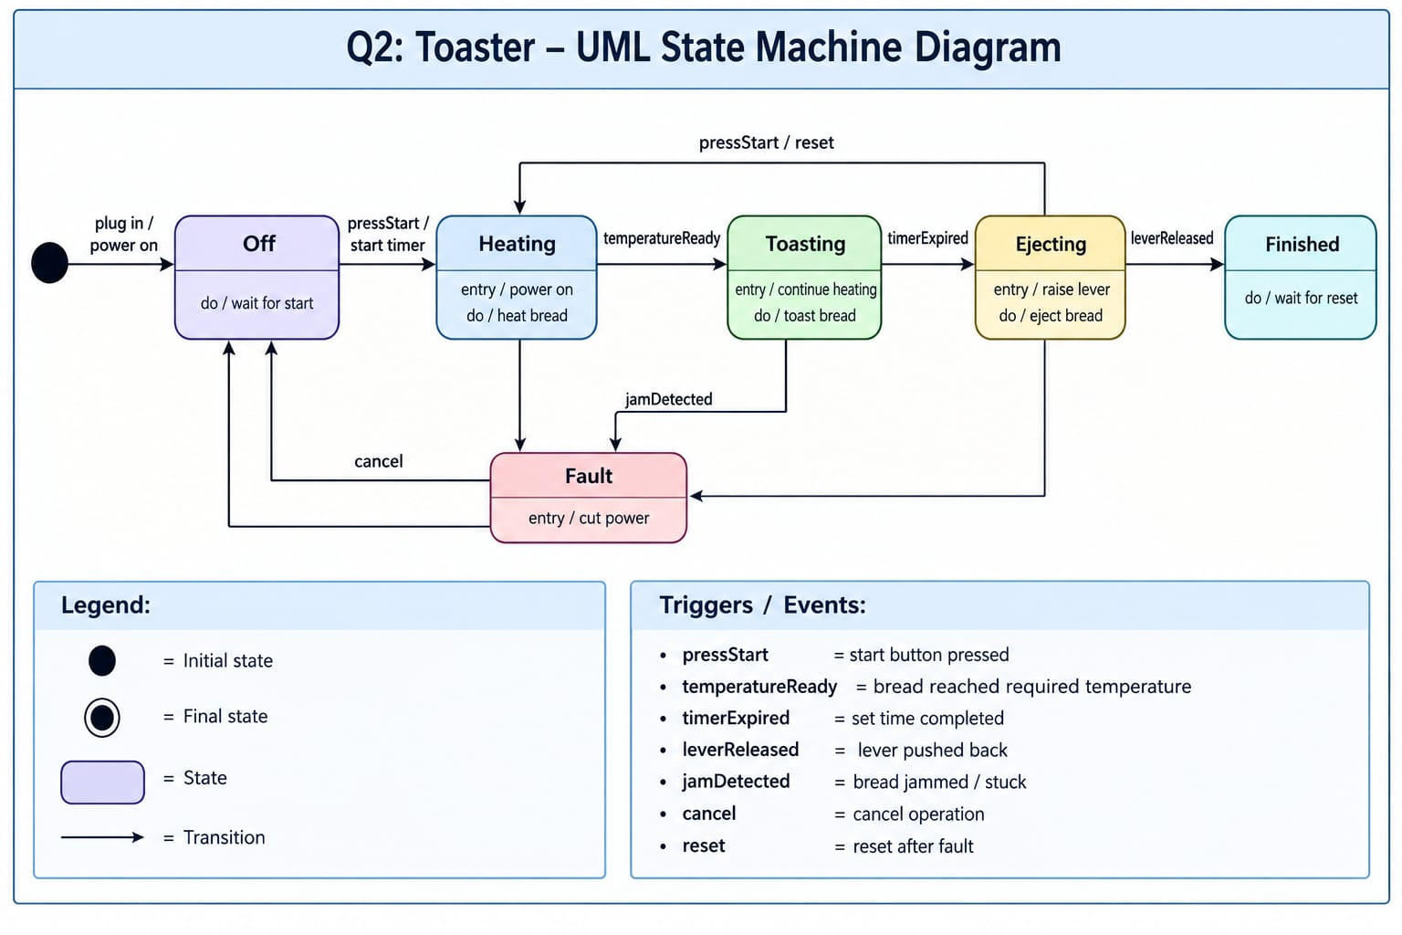

Elevator/Lift — UML State Machine Diagram

Objective
The objective of this task is to draw a UML state machine diagram for an elevator or lift. The diagram explains the different operating states of an elevator, the events that trigger transitions between states, and the actions performed during normal operation and emergencies.

Explanation of the Diagram
The elevator changes its state according to floor requests, door conditions, movement, and safety events. The diagram represents the elevator's behaviour from its initial idle state through movement and arrival, including emergency handling.
1. Initial State
The black circle represents the initial state of the elevator. When the system starts, the elevator enters the Idle state.
2. Idle State
In this state, the elevator is waiting for a floor request, with its doors closed.
When a user requests a floor above the current floor, the requestFloor [target above] transition occurs, and the elevator moves to the DoorsClosing state.
The diagram also shows a transition back to Idle when the doors are closed and there is no new request.
3. DoorsClosing State
In this state, the elevator closes its doors before starting to move.
After the doors close, the elevator determines the direction of movement according to the requested floor.
There are two possible transitions:
- MovingUp: If the requested floor is above the current floor, the elevator moves upward.
- MovingDown: If the requested floor is below the current floor, the elevator moves downward.
This state ensures that the elevator closes its doors before normal movement begins.
4. MovingUp State
In this state, the elevator moves upward toward the requested floor.
The transition is associated with the movingUp [target above] event and condition.
When the elevator reaches the requested floor, the floorReached [target floor] event occurs, and the elevator moves to the Arrived state.
5. MovingDown State
In this state, the elevator moves downward toward the requested floor.
The elevator continues moving until it reaches the requested destination.
When the floorReached [target floor] event occurs, the elevator transitions to the Arrived state.
The diagram also shows an emergency-stop-related transition that can move the elevator into the Emergency state.
6. Arrived State
The Arrived state indicates that the elevator has reached the requested floor.
When the stop [at floor] event occurs, the elevator transitions to the DoorsOpening state.
This state represents the point at which the elevator stops at the destination before opening its doors.
7. DoorsOpening State
In this state, the elevator opens its doors so that passengers can enter or leave.
When the doors become fully open, the fullyOpen event occurs, and the elevator transitions to the DoorsOpen state.
8. DoorsOpen State
In this state, the elevator's doors are fully open.
Passengers can enter or leave the elevator. The diagram also shows an obstructionDetected [any state] event that can cause a transition to the Emergency state.
If the doors remain unobstructed within the specified time limit, the timeout [no obstruction] transition takes the elevator into the Emergency state as drawn in the provided diagram.
9. Emergency State
The Emergency state represents an abnormal or unsafe situation involving the elevator.
The activities associated with this state are:
- Stop the elevator.
- Activate the alarm.
The diagram shows that an emergency stop can be triggered by pressing the emergency button. It also shows that an obstruction detected in the door path can trigger an emergency transition.
After the problem has been addressed and the system is considered safe, the reset [safe] transition returns the elevator to the Idle state.

Events and Triggers in the Diagram
Event | Meaning
requestFloor | A user requests a destination floor.
doorClosed | The doors are fully closed, and there is no new request.
movingUp | The elevator moves toward a higher floor.
movingDown | The elevator moves toward a lower floor.
floorReached | The elevator reaches the requested floor.
Stop | The elevator stops at the destination floor.
fullyOpen | The doors become completely open.
Timeout | The specified time limit expires without an obstruction.
obstructionDetected | An obstruction is detected in the door path.
emergencyStop | The emergency-stop button is pressed.
Reset | The system is reset after the situation is considered safe.
The conditions written in square brackets, such as [target above], specify when a transition is allowed. For example, the elevator moves upward when the requested floor is above its current floor.

Conclusion
This state machine diagram illustrates how an elevator responds to user requests, closes its doors, moves between floors, stops at the destination, and opens its doors. It also represents emergency handling and the reset process. The diagram helps explain the elevator's behaviour and the role of events, conditions, and transitions in its operation.
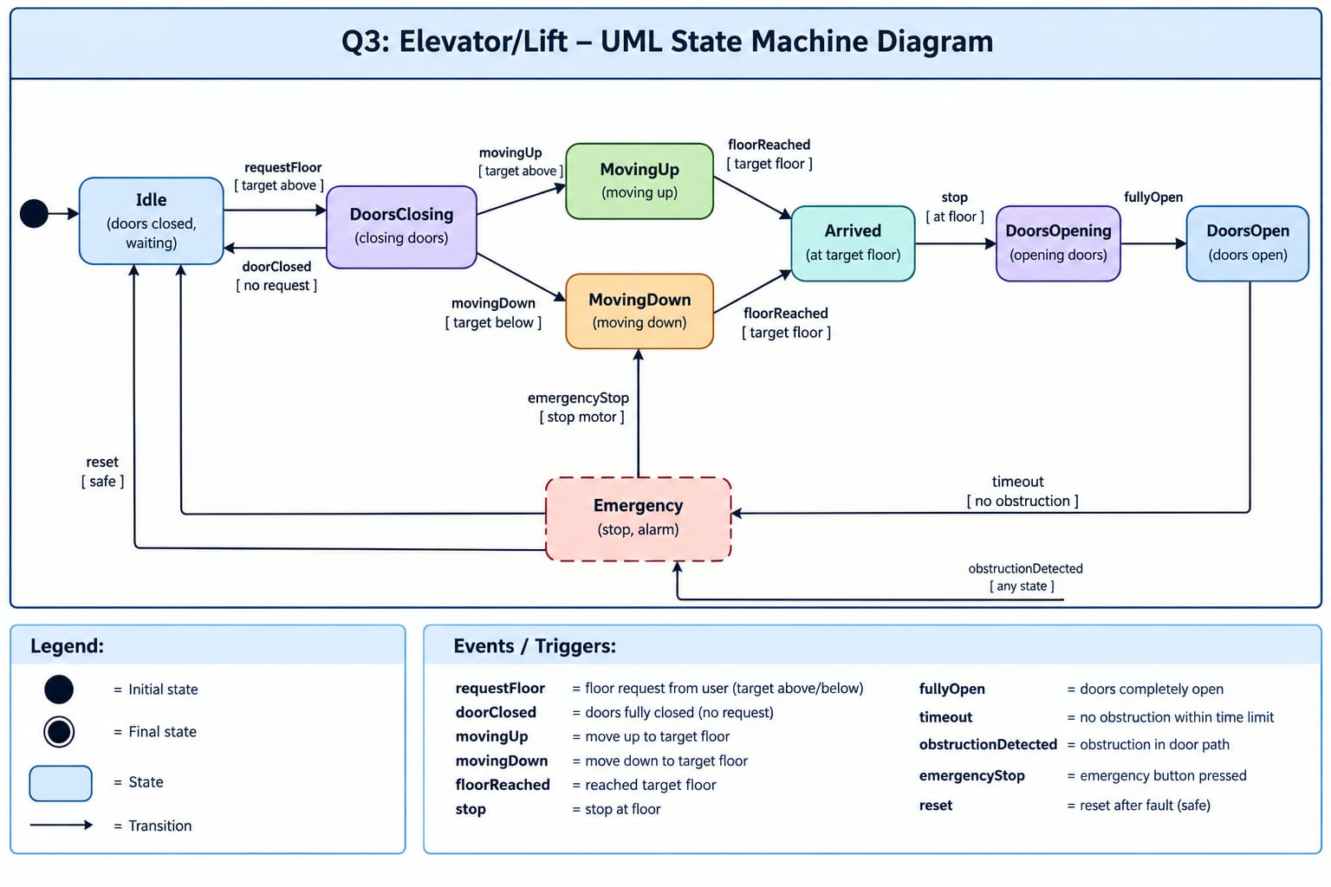

Overall Conclusion of Lab 2
The three tasks demonstrate the use of UML diagrams to represent the behaviour and workflow of software-controlled systems.
- Foodpanda Activity Diagram: Shows the workflow of online food ordering using four swimlanes to represent the customer, application, restaurant, and delivery rider.
- Toaster State Machine Diagram: Shows how a toaster changes states during heating, toasting, bread ejection, completion, and fault handling.
- Elevator State Machine Diagram: Shows how an elevator changes states while responding to floor requests, moving between floors, opening and closing doors, and handling emergencies.
In summary, the Foodpanda activity diagram focuses on the sequence of activities performed by different participants, whereas the toaster and elevator state machine diagrams focus on the states of a system and the events that cause transitions between those states.

